ECE270 Lab 0 Equipment Familiarization

Why are you here today? The real reason is so you can become familiar with the measurement equipment in this lab.

–All of the benches have a:

Power supply:

Oscilloscope:

Signal Generator (built into the oscilloscope):

Digital Multi-meter a.k.a. (DMM or DVM):

This stuff stays in the lab.

There is not equipment at every chair in the lab. This means you will need to pick 1 or 2 lab partners depending on where you sit. Some benches have 1 set of equipment per 3 chairs and others have 1 set of equipment for 2 chairs.

You purchased a handheld multi-meter, scope probes and breadboards for use in this lab. These are yours and you should take them with you as you come and go.

You can use the benchtop DMM and/or your handheld DMM to make some of the measurements for this lab. You will be told to use a certain one for a few measurements. The scope probes are complicated enough to warrant a description for getting good measurement results so that description follows later when you start using the scope to make a few measurements.

In the todays ECE270 lab you will use a Power Supply, Digital Voltmeter (DMM), Signal Generator and Oscilloscope. You can/should also use your hand held DMM along with the tabletop DMM. The following pictures show what the DC Power Supply, DMM and the handheld DMM look like. The Oscilloscope will be shown later.

The Power Supply. Figure 1 shows the power supplies we have in the 270 lab. They have 3 separate supplies but we will only use 1 of the 3 today. Figure 6 and 7 show the DMM (Digital Multi-meters) we have in the lab. The table top version (Fig 2) and your handheld version (Fig 3).

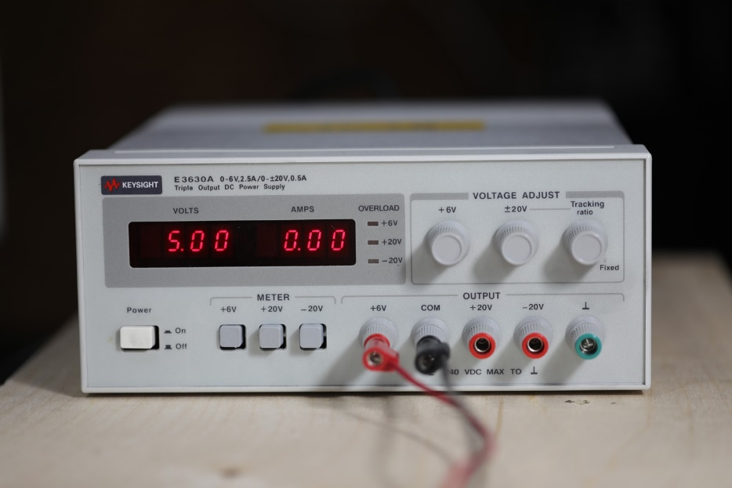

Figure 1: Triple Voltage Power Supply.

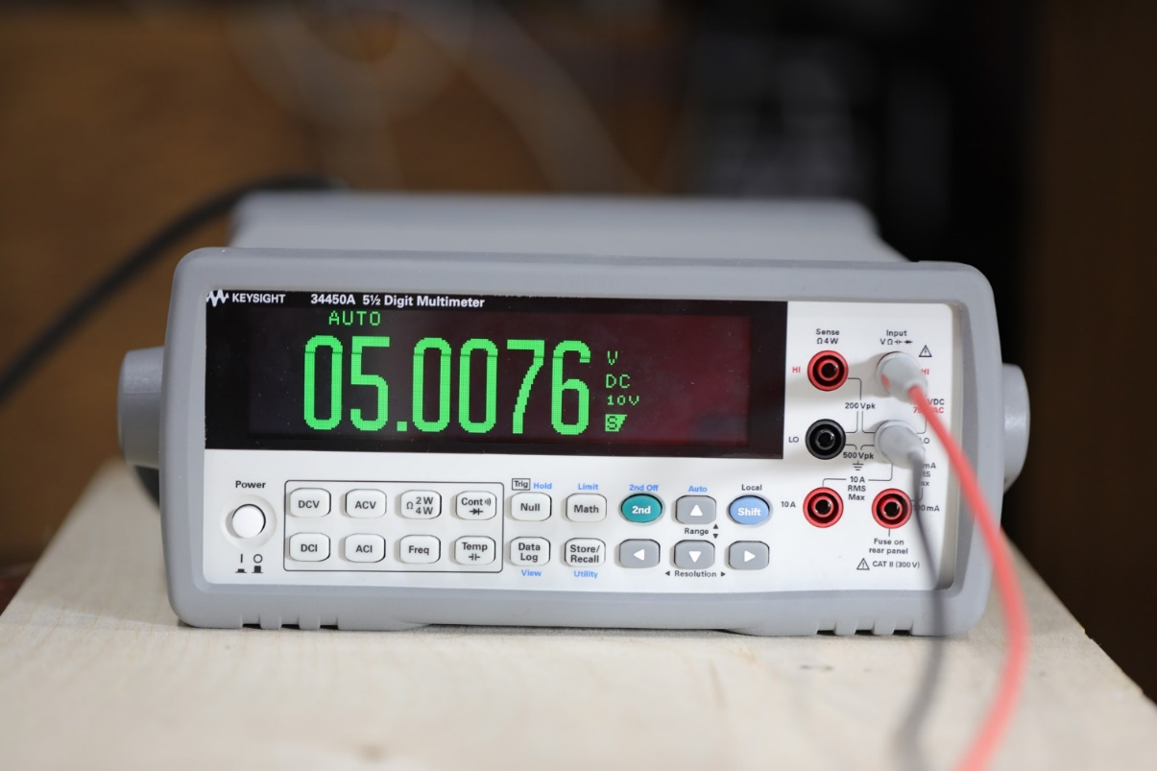

Figure 2: Table top DMM with leads for measuring voltage or Ohms.

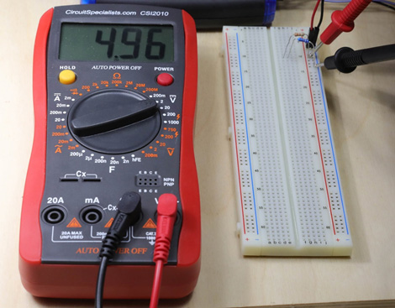

Figure 3: Hand held DMM and breadboard.

**Let’s get started:**

**Voltage Measurement:** To get started you will build the circuit shown in Figure 4 on your breadboard, connect a voltage source to the circuit and make some measurements using your DMM.



Figure 4: Test setup.

In order to build this on a breadboard you need to know how the points are shorted together on the board. Here is the figure for your convenience.

The breadboards we use have internal connections which short the square ‘holes’ together as shown in Fig 5.

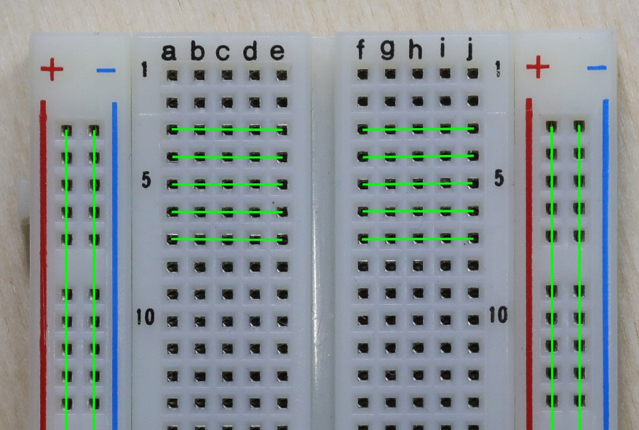

Figure 5: Depiction of how the breadboard shorts holes together.

The green lines show that abcd and e of each row are shorted together. The same is true as well for fghi and j on the other side of the wide channel. There is a gap between e and f right where the channel is. The rows are not shorted together across this divide. This divide is exactly the width of an integrated circuit such as an op-amp. This shorting scheme is repeated for all 64 rows. **Note** not all of the shorts are shown in the figure. Our boards also have shorts as shown by the vertical red and blue lines along the right and left sides of the breadboard (proto-board). The shorts run the whole length of the board as indicated by the green vertical lines. This is where power is usually supplied to the circuitry on your breadboard.

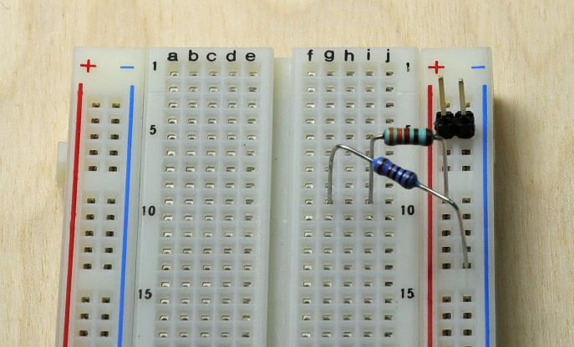When laying out the circuit I suggest you minimize the wires you use. It makes modifying and debugging the circuit much easier. A simple layout with 2 resistorsis shown in the figure to the left (from figure 4). Notice the red and blue lines running vertically. They connect from one end of the board to the other as mentioned above. I usually use these for power when I can. I will connect the +5V signal to red and GND to blue. These will come from the power supply.

Figure 6: First Breadboard circuit.

Before you build the circuit on the breadboard you should use the DMM to measure the resistance of the 2 resistors you will build the circuit with. Don’t hold the leads in your hand as it may change the value of resistance you read. I recommend you put the resistors in the breadboard as similar to the resistors in figure 6. Then use put the tips of the DMM leads in the same holes that the leads of the resistor are plugged in. Right down the resistor values. R1 ___3.2638kΩ_____, R2 ____9.9874kΩ____

In the schematic shown in Figure 4 there is a yellow circle marked with 5V and Power Supply. This is in fact where the power supply gets connected into the circuit you build on the breadboard. The red wire from the (+6V) terminal of the power supply as shown in Fig. 1 is connected to the resistor (R1). The voltage that is supplied is indicated on the LEDs of the power supply. Set the voltage to 5V before you hook it up to the breadboard. The black wire from the power supply is connected to the node with the GND symbol. You won’t be able to measure any DC voltages without connecting the DC power supply to the circuit in this manner.

So one end of R1 ultimately goes from the +5V Power supply terminal (red wire) with the other end going to R2. The other end of R2 gets connected to GND. The symbols that are noted as TPx (test points) are not actually a physical part. They represent locations where you will connect probes to make certain measurement.

Measure the +5V supply with the DMM. Connect the red lead of the DMM to a node where the red lead of the power supply is connected. Connect the black lead of the DMM to a node where the black lead of the power supply is connected. Figure 7 below shows the best way to “connect” the probes to the breadboard circuit. The “best” being that the probe tips are touched to the resistor lead right where it enters the bread board. This is the round peg square hole trick to force a good connection.

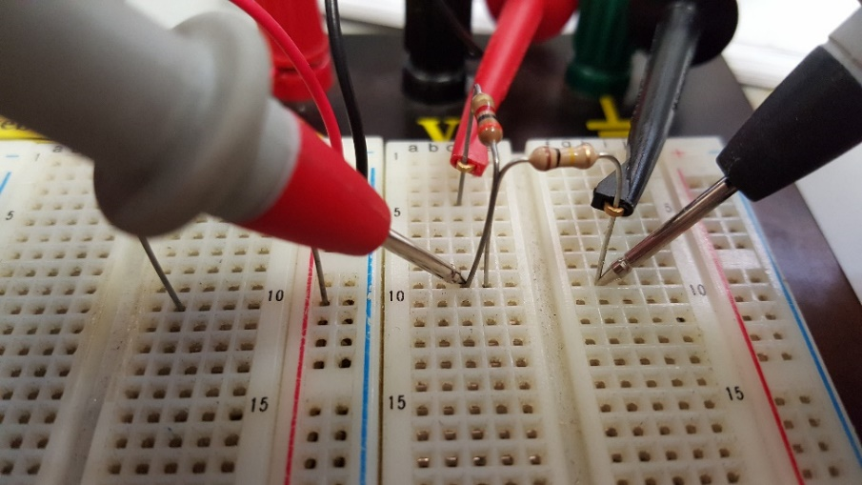

Figure 7: Breadboard with 5V and DMM probe connections.

Use the correct range for DC volts. It is manually adjusted on the handheld meters and automatically adjusted on the tabletop meters. Correct is the range that is the next higher range than the voltage you are measuiring. In the future if you don’t know the voltage start with the highest range and lower the setting until the range is just larger than the voltage. In this experiment you know the voltage should be 5V so you can just choose the 20VDC range. Remember to get a reliable connection you should put the tips of the meter into the same holes as the resistor leads or any wire leads of the same node.

5V supply value _________5.00_______ V

Measure the voltage across R1 and R2. You will be able to lower the range for the voltage across R1. You usually want to optimize the range so you get the most accuracy the meter can provide for your measurement.

VR1 ______1.2354_______ V. VR2 ______3.7757_______ V.

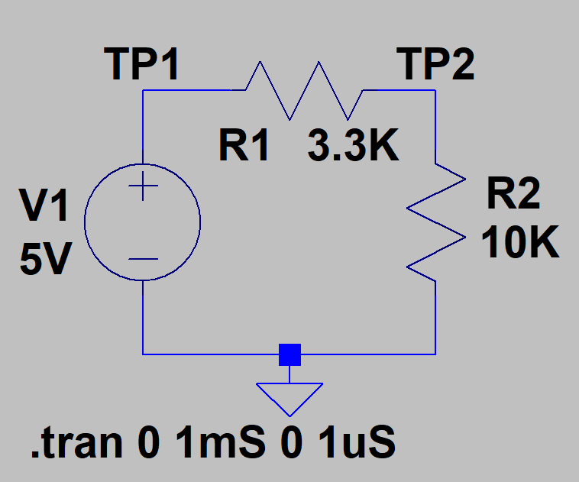Check to see if the voltages you measured are correct. Figure out what is wrong if they aren’t close. To determine what ‘correct’ is make this circuit in LTSpice. You get LTSpice from the Analog Devices website. It is free and it works well. Install it on your own computer now or use it on the computers in the lab. Start LTSpice and open a new schematic. Short cut keys to do many of the functions are shown in a document on the 270 website.

Add a resistor by pressing the R key. Place 2 resistors in the schematic. CTRL-R will rotate the resistor so R1 is horizontal. You can rotate it after you place it if you like by pressing F7 then clicking the resistor and then CTRL-R.

The voltage source is in the component list. Edit Component or F2 brings up the list of parts. Start typing Voltage and the voltage source should come up. Place the source on the schematic. You can adjust the parameters of almost anything in the schematic with a right mouse click on the device. Connect the parts together with wires. Use F3 to start drawing wires. Finally add a ground symbol to the drawing using the, you guessed it, G key. Connect the GND with a wire to the correct node. Set the voltage and resistor values by left clicking on the V or R letter. If you use the actual values of the measured V and R’s your simulation will be very accurate. The other choice is to use 5V and the nominal values of the resistors 3.3K and 10K, Add the TP1 and TP2 labels by pressing F4 and entering TP1 or TP2 and placing them on the appropriate wire. The .trans statement can be added by clicking the run icon and entering the start, stop and maximum timestep into the menu that pops up when you do this. Draw a wire from TP2 to the right for several steps. Right click on the wire and Place .op Data Label there. This gives the dc value at this test point. So the voltage across R1 is (5-TP2) volts. The voltage across R2 is the voltage at TP2. An alternate way to display the voltage is to hover the cursor near TP1. When it becomes a red probe (not a clamp) click and hold the left mouse button and move to TP2. Place a second grey probe here and LTSpice will plot the voltage across R1 as the voltage difference, V(TP1,TP2).

So what are the VR1_SIM _______1.2406______V and VR2_SIM ______3.7594_______ V from the simulation?

Do the measured voltages agree with the simulated voltages? (Yes) sThey are probably close but not exactly the same if you used the nominal values in the simulation. They are probably very close if you used the measured values of the V and R’s in the simulation.

You just measured an easy thing to measure. The voltage across a resistor or power supply. The next type of measurement is more difficult. It is to measure the current flowing through the resistor. The next section describes how to do this without blowing a fuse or killing the power supply.

**CURRENT MEASUREMENT:** I pulled this next measurement from lab 1. I’m doing this because it usually causes people difficulty until they do it a few times. So here you can get some practice without losing any points for incorrectly measuring something.

In this part, you are required to measure the current flowing through the resistor R1 (IR1) in the circuit given in figure 8. For R1 use an 887Ω resistor. Measure the resistor with the DMM before you put it into the circuit.

R1 = ____886.08____ Ω. Measure the 5V supply as well with the DMM.



Figure 8

Connect the circuit as shown in figure 8 on the proto board. For this setup, the power supply is a 5VDC voltage source. On the DC supply the voltage connections go to +6 and COM as done in the voltage measurement procedure. Don’t use the green connector with the ┴ symbol. This connector is actually tied to the ground pin on the AC outlet. It is not the power supply ground.

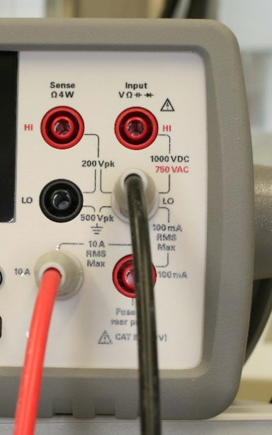Set the DMM such that it measures Amperes (‘DCI’). You also have to put the red test lead into the ‘10 A’ jack on the DMM. Press the range arrow until the range is 1A as indicated by the green text in the DMM screen. Auto scale does not use the 10A input port so you have to manually set it to 1A.

* Connect the DMM **in series** with the resistor R1 to measure the current through R1. This has to be done because current is a “**through**” variable. To make a current measurement, the DMM has to be connected as shown in Fig. 9.



Figure 9

* For this connection you have to physically connect one end of R1 to the GND of the power supply using the DMM as a wire. Normally there is a wire connecting R1 to GND. Here you are replacing the wire that goes from the supply GND to the resistor with the DMM for measuring the current. When the meter is in current mode it acts like a short circuit between the red and black input wires. So don’t put the leads across a voltage or you will short out the voltage you are trying to measure.

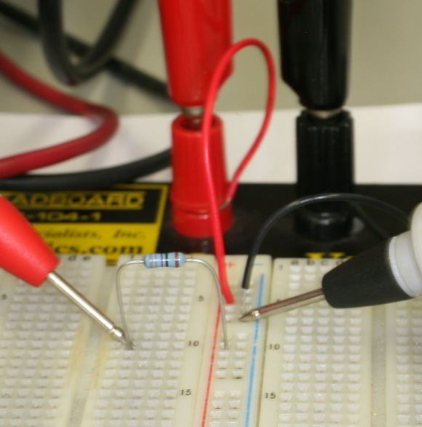 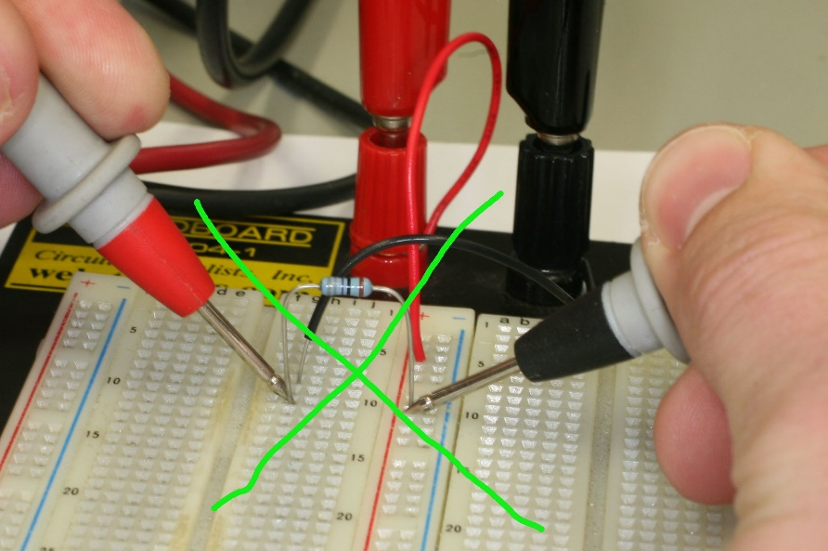

Figure 10a Correct Figure 10b Incorrect

* Figure 10a shows the resistor connected to the supply rail **through** the DMM leads correctly so the current must flow *through* the resistor then the DMM to GND. It is hard to tell because the depth of field is poor but the black test lead is touching the black wire which comes from the power supply common. The meter leads are finishing the connection of the resistor to GND as though they represent a piece of wire.
* Figure 10b shows a typical incorrect method. The probes are *across* the resistor that we are trying to measure the current *through*. This will short out the resistor and result in a very high current flowwing.
* Once, you have the correct setup, read the DMM display to get the value of IR1. IR1=______0.0056376________A

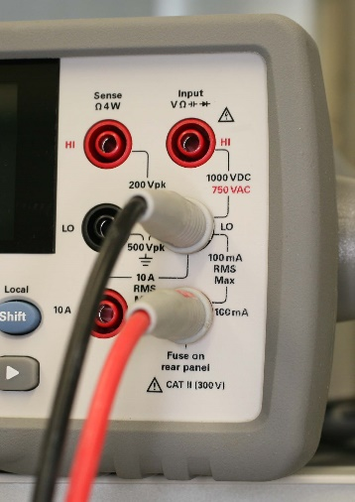Note: If the value of current is in the mA range then you are measuring the current correctly. You can then change the red lead at the DMM to the 100mA red connector to get a more accurate reading of the current. Change the range to Auto or mA to get a reading using the 100mA input.

* You can also calculate the current through R1 by measuring the Voltage drop across R1 and dividing it by the Resistance of R1 i.e. IR1 = VR1/R1. For calculating the current in this manner, implement the following steps:
  + Reconnect the circuit as shown in figure 8.
  + Set the digital multi-meter (DMM) to measure voltage (and put the red lead at the DMM into the V jack!). Now you can safely use it to measure voltage across resistor R1. VR1=_______5.0076________V
  + Calculate the value of IR1 = VR1/R1 = ______0.00565_____ A. How does this value of current compare to the value of current you found in the previous step?
  + --Almost same.

Next we will use an AC signal source instead of or in addition to the DC source. This is not much more than replacing the DC power supply with a signal generator output. The real difference comes in when you make the measurement. A DMM can measure AC voltages but it doesn’t tell you much about the waveform. What does it look like for example. Because it is important to know what the waveform looks like in many situatiuons we want to see it. In order to see it we will use an Oscilloscope to look at it.

Before we change over to the AC source and look at it with a scope I want to point out that there are many ways to quantify AC voltage. Some of the more common are volts peak, volts peak to peak and volts RMS. These are all used and you should understand the differences.

**Volts peak**, VP, AC only amplitude. VP is used for quantifying the amplitude of a symmetrical waveforms like a sine wave where the top half of the waveform is the same size and usually shape of the bottom half. In this case specifying the peak voltage tells you all you need to know about the amplitude. Many signal generators use VP for the amplitude of symmetrical waveforms.

**Volts peak to peak**, VPP. AC only amplitude. VPP is used to quantify any waveform symmetrical or asymmetrical. It is a value which tells the voltage between the maximum and minimum of the waveform. It does not indicate the DC value (or offset) of the waveform.

**AC RMS**, tells the RMS value of only the AC portion of the waveform. It ignores the DC component of the waveform. You learned in ECE230 that the RMS value gives the voltage equivalent in DC of an AC signal. The equivalence is the DC signal and the AC RMS signal will dissipate the same power in a 1Ω resistor.

**RMS**, tells the RMS value of a waveform considering both AC and DC components of the waveform. To get RMS you have to take the SQRT[(AC RMS)2 + DC2]

Finally **DC**, gives the offset of any AC signal. This is often 0. For example when you have a sine wave that goes from 1V to -1V the energy above 0 is equal to the energy below 0 yielding an offset of 0. A 2VPP with 1V offset would yield a sine wave that went from 0V to 2V.

OK those definitions are given. Next we will look at measuring AC signals. Usually this is done with an Oscilloscope. The following figure shows the scopes we have in the lab with a built in signal generator. The figure shows the signal generator connected to a circuit with the oscilloscope inputs connected to the circuit for making measurements. Now a detailed description of what you see there followed by all the things you have to do to get the traces on the scope.

The circuit is similar to figure 4 above. The black cable from the oscilloscope is the signal generator output. The yellow voltage source usually has a name, frequency and voltage. We are now using the signal generator to provide the input signal listed in the source icon.

Look at the figure below. The scope channels 1, Yellow, and 2, Green are connected to the circuit in a few spots. The channels are different colors so you can easily see which channel is giving which signal. There are 2 scope probes used in this setup. This requires some special setup the first time you do this. The probes themselves need to be adjusted once that description of that also follows. In fact you will Fig. 11: adjust (calibrate) your scope probes next.

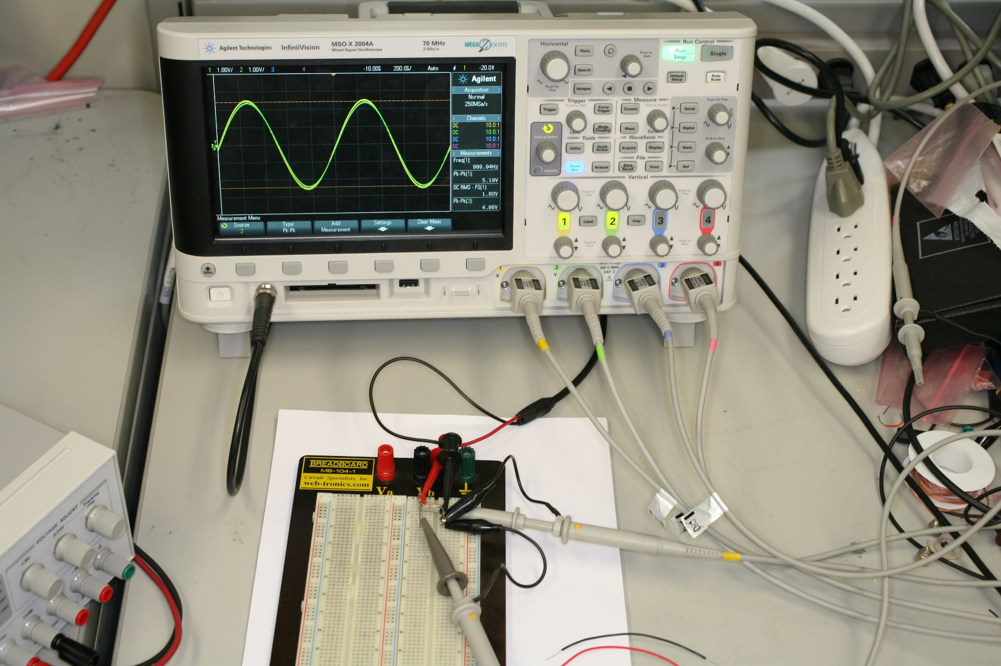

Mostly you want to connect the input of the scope to the point in the circuit where you want to see the voltage, Simple right. Well kind of. The oscilloscope usually needs a scope probe. You had to buy some for this lab. One end of the scope probe has a BNC connector which connects to the input on the front of the scope. The other end looks like a probe with another wire attached. The probe typically connects to the node in the circuit you want to measure. The scope probe also has a black lead with an alligator clip on it. This clip has to be connected to the circuit ground. Always!



The scope probes you have are used to connect to nodes in the circuit you are examining so you can see the voltage at that node. Each probe has a slide switch on it which allows the signal come through unchanged ( X1 setting). The X10 setting divides the signal that the probe is connected to by a factor of 10.

For example a 10V signal would appear as a 1V signal at the scope.

Usually you will use the X1 setting. So why would you ever want to divide the signal down by 10. Two main reasons. The signal is very large and would be too high in voltage for the scope to measure. The other reason is that by connecting a probe to a circuit you are loading the circuit with the probe and oscilloscope. In the X1 mode the load is equivalent to a 1 Mega Ohm resistor. Loading a circuit with 1 MΩ resistor usually doesn’t change the measured voltage results much. Sometimes it does, for example if the circuit you are measuring has large resistance like 100KΩ then 1 MΩ will change the voltage you measure by 10%, too much. When this happens you can use the X10 setting and the load the probe represents is a 10MΩ instead of a 1MΩ. This reduces the change in voltage that connecting the probe to the circuit causes resulting in less error. You will sometimes need to use the 10X setting for some measurements.

A few more complications:

1: The scope has a setting for the scope probe voltage division ratio. You should use 1.00:1 for 1X and 10.0:1 for 10X. That scope setting makes sure the scope correctly identifies the amplitude of the voltage when you use the scope measurement functions.

2: In the 10X mode the scope probe needs to be calibrated. What does that mean? Calibration using a very simple explanation allows the probe to measure the voltage correctly. The following description should help clarify how things can go wrong without a well calibrated probe.

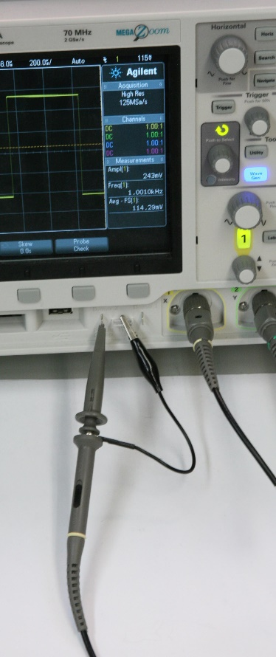 If you have never used an Oscilloscope before there is a description of the basic functions in the Appendix. Please read it. It is short and explains the necessary buttons to push to get you started measuring useful data.

The scope has a built-in square wave output to make it easy to adjust the probe calibration. See picture to the left. Just connect the probe tip and black ground connector to the square wave test points and see what you get. If the square wave is rounded or has a pointy overshoot then the probes need to be adjusted. See figures 11a and 11b below.

To calibrate a probe have it connected to the calibration square wave generator as shown in the figure to the left. It is built into the scope. Make sure the probe is set to X10. Calibration is only possible on the X10 probe setting. X1 does not need any calibration. Turn the trimmer in the hole on the scope probe base (near the BNC connector) with a plastic screwdriver that came with the probe. Make the signal overshoot and undershoot (see figure 11). Make sure you measure and record the peak to peak voltage of the calibration wave form when it is rounded (undershoot) and peaky (overshoot) the maximum amount for **the post lab quiz**. Now adjust the calibration until the waveform looks like a square wave with no under or over shoot and measure the correct waveform voltage.

VROUNDEDMAX(undershoot) ___0.23985V___ VPP, VPEAKYMAX(overshoot) ____0.36985V___ VPP, VPERFECTSQUARE ____0.23985V___ VPP

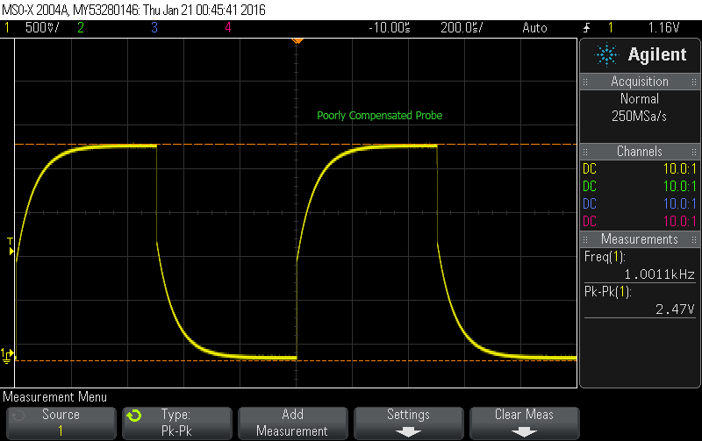 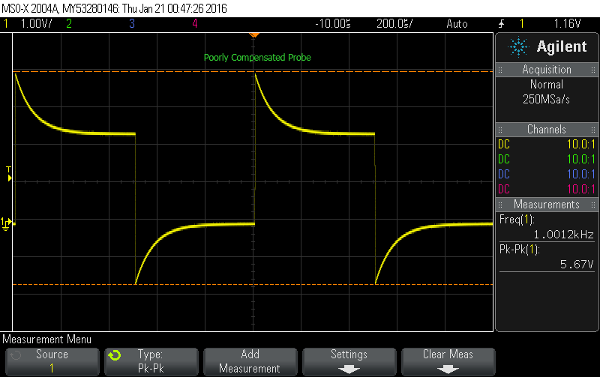

Figure 11a (undershoot or undercompensated) and 11b (overshoot or over compensated)

**I STRONGLY SUGGEST** you put the colored rings on the probes so it is easy to identify the channel number a certain probe is connected to. The colors match the oscilloscope channel colors used on the screen.

Calibrate all of your probes and your lab partners probes now!

One very nice feature of most digital oscilloscopes is the ability to measure parameters from the displayed waveforms. You can have the scope easily measure some useful parameters of the signal (VAVE, VPP, VP, VRMS, Frequency) for example. To add a measurement, you press the ‘Meas’ key. This brings up the soft menu below the display. You can pick which channel you want to measure and what quantity you want to measure, Then when you have selected those 2 things you can Add the measurement to the display. That’s it for the most part.

Before we make measurements there is one last thing to do with the Calibration. I want you to purposely make a measurement with correctly and incorrectly calibrated probes to see if it matters that they are calibrated.

**Revisit scope probe adjustment.** You are going to purposely misadjust the scope probes to see if it really makes any difference to your measurements. You will:

* 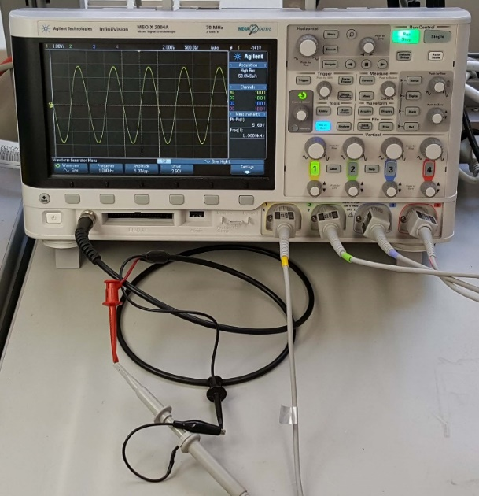Connect a correctly calibrated scope probe set to 10X to CH1.
* Connect an undercompensated* scope probe set to 10X to CH2.
* Connect an overcompensated** scope probe set to 10X to CH3.
* Set the signal generator to put out a 5VPP 1KHz sine wave.
* Turn on CH1, CH2 and CH3 if they aren’t already on.
* Connect all the scope probes to the signal generator output using the BNC to mini clip cable as shown in Figure 12. You can use the breadboard if you want to. Measure the peak to peak voltage.

*Connect the probe to the calibrator as before. Adjust the trimmer so the scope image looks like a rounded square wave (Figure 11a). Make it as bad as you can.

**Reconnect another probe to the calibrator. Adjust the trimmer so the scope image looks like a second peaky square wave (Figure 11b). Make it as bad as you can. Turn on the VPP measuremtns for CH1, CH2 and CH3. Record these measured values.

Figure 12:

CH1-VPP_CORRECT = _______0.249V______ VPP.

CH2-VPP_UNDERCOMP = _____0.249V______ VPP

CH3-VPP_OVERCOMP = _____0.378V_______ VPP.

Did the compensation matter? ________Yes_________

**Make all probes correctly calibrated again**.

Now you will learn how to generate an AC waveform and make some measurements on the scope using some ‘Meas’ commands.

Back to circuit shown in figure 11. Build it. Connect the sig gen output to R1 as shown in Figure 11. Connect the CH1 probe to TP1 and the CH2 probe to TP2. Make sure the probes are set to 1X.

Push the Wave Gen button to turn on the signal generator. The key turns Blue when it is on. When you push the Wave Gen key the soft buttons will allow you to set the Type of Waveform. For now use Sine wave. For frequency use 1KHz. For amplitude use 5Vpp. If it only goes to 2.5Vpp then press settings and change Output Load to Hi-Z. Offset use 0V. This should result in a sine wave that is +- 2.5V

There are usually 2 important things to set on for the scope display. They have to do with the displaying of the waveform. X (Horizontal) and Y (Vertical) in the display are usually set by the Time base, (X) and the V/div, (Y) settings on the scope. Set the time base to a time value that gives a good looking waveform on the display. So what does that mean? If you have a 1KHz sine wave the period of the sine wave will be 1/f or 1mS. There are 10 major divisions in the Horizontal direction. Pick a time that gives somewhere between 1 and 10 cycles of the sine wave. 1 cycle is 1mS and 10 cycles is 10mS. To get 1mS over 10 divisions you need 1mS/10 or 100uS/ div for the time base. To get 10 cycles you need 1mS/ div for the time base. Set the time base for what ever frequency you happen to be looking at so you get a useful display. It might not be between 1 and 10 cycles but it will usually be somewhere in there.

The vertical setting V/div is usually easier to pick. You want to see the whole waveform and you want it to almost fill the screen. The number of divisions for the vertical display is 8. If you have 5Vpp then your biggest display is 5/8 V/div. This is 0.625V/Dv. Unfortunately, that isn’t available. Our scopes have a 1/2/5 choice. 0.5V/div or 1V/div or 2V/div or 5V/div etc. For your sine wave 1V/div makes it the largest without clipping the waveform off at the top or bottom of the display. So pick 1V/div.

Once the waveform is displayed without clipping you can have the scope make useful measurements. To get them you push the ‘Meas’ key. So do that now.

Select the Source CH1 using the soft keys. Then select peak-peak under the type of measurement. Add this measurement. Select CH2 and add this measurement. The display should now give you the Vpp measurements. Make sure the trace is fairly large on the screen by adjusting the V/div. This makes the measurements as accurate as possible.

CH1 now measures Vsin. CH2 measures the voltage across R2. This suggests a potential problem with using the scope to measure voltages. We can’t really directly measure the voltage across R1. This is because the scope probe always needs the alligator clip connected to GND. Since neither side of R1 is connected to ground the voltage cannot be measured directly. Fortunately the scope has a function built in to allow us to determine this voltage. It is done with a MATH function.

Now press the MATH key. Select the – operator, set source 1 to CH1 and source 2 to CH2. The small knobs to the right of the MATH key allow you to adjust the volts per division and position of the math waveform. Note if you push the position knob it position will be set to the middle of the display. Now MATH shows Vsin – VR2 which is VR1.

**Quick note** **on “Cleaning up”** the measured waveforms. Adjust the volts per division knob to get the largest sine wave that doesn’t clip displayed on the screen. In this case clip is when the sine wave is larger than the screen can display. It may look like a sine wave with flattened ends. To help with this problem we can “clean” up the displayed signal. Press the Acquire button (2 left of MATH). Push the Acq Mode and pick Hi Resolution if it isn’t already selected. Pick Normal if Hi Res is already selected. The displayed waveform should be much better in hi res mode compared to Normal resolution. For signals that repeat like the sine wave you can also clean up the noisy display with averaging. For averaging to work you must have triggering functioning. Make sure it is. Triggering is explained in the appendix. Then try averaging instead of Normal or Hi Resolution. Try different amounts of averaging to see how it works. Make sure you leave averaging at 512 for the next test. Change the frequency by at least 100Hz and see how the display responds with averaging set so high. This is a weakness for averaging. It takes a long time for low frequency signals. **End of Note.**

Add a new measurement to the display. Press Meas and select CH1 and use type AC RMS- N Cycles. Add this to the display. Add the same type for CH2. What are all the measurement values?

VTP1____4.979V___ PP, VTP1____1.7624V____ RMS, VTP2____3.727V___ PP, VTP2____1.3172V____ RMS

Turn on the benchtop DMM and use the AC measurement mode. Measure the TP1 to GND and TP2 to GND voltages.

VDMMTP1 _____1.7587V____, VDMMTP2 _____1.3188V_______

What type of units should this voltage have based on the scope measurements? Volt

Now on the scope add a measurement for the MATH CH and use type AC RMS- N Cycles. Adding a 5th measurement will automatically remove one of your 1st - 4 measurement. You can also manually remove them yourself if you want to control which ones are on screen.

VMATH _____0.44227V_____ RMS

Measure the voltage at TP1 with respect to TP2 with the DMM. Red lead at TP1 and Black lead at TP2.

VTP1-TP2 ________0.43803V_________ RMS

Did this measurement match the scope measurement for MATH? ______Yes_________

After this you should realize that the DMM can measure voltages without having either lead connected to ground while the scope has to have the alligator clip connected to ground always.

**One final exploration of measurements. Effects of Measurements on the circuit:** When making measurements on a circuit we want to measure voltages without changing the circuit as we make the measurements. Usually this is easy however sometimes it is not. You are going to measure some voltages several ways to see how you can change the circuit just by measuring something and what you can do to prevent this from happening.

* On the breadboard replace R2 with a 200KΩ resistor.
* Set the Sig Gen to a 1KHz - 5VPP sine wave with no offset.
* Disconnect the scope probes from the circuit.
* Measure the voltage across R2 with the DMM. VR2DMM ______1.731V_______RMS.
* Set the scope probes to X10.
* Set the scope to use 10.0:1 probes
* Connect CH2 scope probe to TP2 (tip) and ground (Black).
* Measure the voltages TP2 using AC RMS- N Cycles.

VTP2X10 ________1.7062V_________ RMS

Repeat the measurement with the probes at X1 and the scope with the 1.00:1 settings.

VTP2X1 _________1.7219V________ RMS

Were any of the measurements similar (<2.5% deviation)? Which ones?

All three measurements are similar (<2.5% deviation).

Were there any significant differences (>5% deviation) between any of the measurements at the same TP between the X1, X10 and DMM measurements? If so which measurements.

None.

**This is why some of the measurements are different:** When you attach a scope probe to the circuit it is the same as connecting a resistor to the circuit between the scope probe tip and ground. Using the X1 scope probe setting the resistor that you are ‘adding’ to the circuit is 1 Mega Ohm. Using the X10 scope probe setting it is the same as adding a 10 Mega Ohm resistor to the circuit. Ideally the measurement should add an infinite ohm resistor so it doesn’t change the circuit. The ‘added resistance’ that is the largest will change the circuit less than the other ‘added resistances’. You did or will learn why adding the resistances to the circuit changes it in ECE230.

**NOTE:** The DMM has either a 10 Mega Ohm or >1 Giga Ohm resistance depending on the settings of the DMM. Usually it is set to 10M Ohm in this lab.

That’s the guided tour. Play around if you want to know what else the scope can do.

Appendix: Simple description on using the Keysight MSO-X 2004A Oscilloscope.

First the front screen.

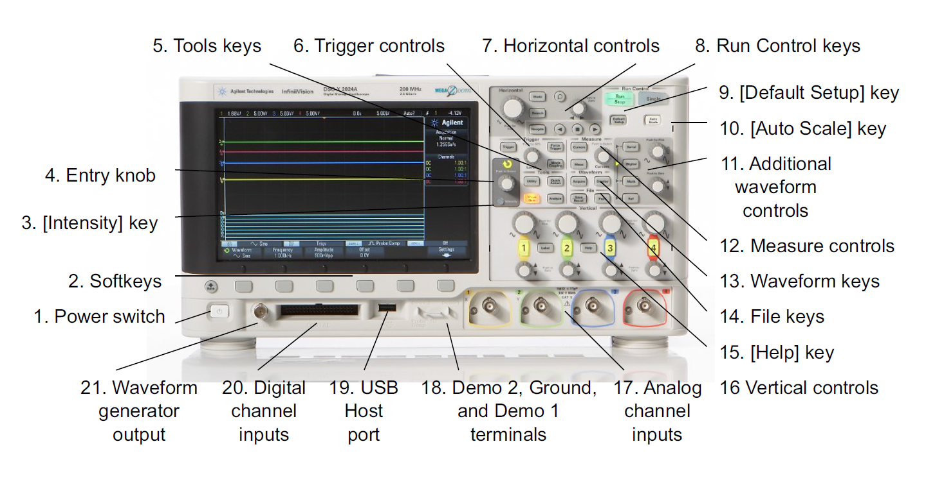

The Softkeys and Entry Knob will get used a lot when running the scope. Let’s define the leftmost softkey as key #1 with the rightmost as key #6.

**Setting up the measurement channels:** Vertical controls are used to turn on and setup the measurement channels. Any channel that is enabled will have the number lit up as the picture shows. Depress the number button of the channel you want to adjust. A menu will show up above the softkeys. #1 sets the coupling of the input to the probe. AC means all DC signals will be blocked by a series capacitor built into the scope. DC coupling allows AC and DC signals to pass into the scope. We usually use DC coupling. #4 sets fine or course range adjustment. Course adjustment sets the volts per divisions in a 1-2-5-1 sequence.1V/div, 2V/dIv, 5V/div etc. This is usually good enough for most measurements. #6 is to set the probe value. We use 10:1 probes. The probe ratio is displayed on the right hand side of the screen. If they are not at 10:1 then use the probe softkey to adjust the setting to 10:1. This tells the scope what the voltage value is that is being measured. So for a 10:1 probe a 1V signal at the input is really a 10V signal at the probe tip.

**Setting the Horizontal time base:** For most of your measurements you will only use the large knob which changes the time per division. Once again in course mode the sequence is 1-2-5-1. The course or fine mode is toggled by pushing the large knob in the Horizontal group.

**Setting Triggering:** Triggering determines when the scope draws the images on the screen. Press the “Trigger” bottom just above the Entry knob. This brings up 3 soft keys. #1 sets the Trigger Type. You will usually use ‘Edge’. #2 sets the input channel that will be used for the trigger signal. #3 sets the Slope of the trigger signal. You will usually use rising or falling slope. The small knob marked level is the 4th adjustment you will usually use. There are 2 modes of triggering. Auto and Normal. The mode is indicated in the upper right part of the scope display. In Auto mode the scope will watch for the trigger event you defined for example Rising Edge at 2 volts. If this event never happens the scope will trigger anyway. In Normal the scope watches for the event and only triggers when the event occurs. To set the trigger mode: press “Mode/Coupling” which is the button to the left of the ‘Entry” knob. Softkey 1 selects Auto or Normal.

A description of what trigger does is useful here. The scope will display images of the waveform. When the display is drawn is determined by a trigger event. So for example in this lab we want to watch the voltage across the capacitor. This is measured with channel 2. The voltage across the capacitor is almost a square wave going from 0 to 4 volts and 4 to 0 volts. For convenience we will trigger the drawing of the images when the voltage crosses 2V. In one case we want the voltage to be rising from 0 to 4 when we trigger. This happens when the capacitor is being charged. In another case we want to trigger when the voltage is falling from 4 volts to 0. This happens when the capacitor is being discharged. So in this lab you set up the type as ‘Edge’ on channel 2 with a rising edge. Next all we need to do is change the trigger to a falling edge when we want to see the discharge. The push of one trigger button and the whole image changes.

Special Instructions for measuring DC only. Set the trigger type to Auto. That’s it.

**Cursors:** You can have up to 4 cursors on the screen. 2 horizontal (voltage) and 2 vertical (time). Press the Cursor button. 4 softkeys come up. #1 set to manual mode. #2 choose the channel that has the voltage you want to know the value of. #3 sets which cursor the ‘Entry knob’ will control. You will need to place X1, X2, Y1 and Y2 y choosing which one you want to move and placing them with the Entry knob. Once the 4 cursors are in place you can read the deltas between them on the screen.